Partner Agencies  Arkansas Workforce Center prides itself in being a “One-Stop” Center where individuals can visit our offices and be connected with multiple resources and agencies to help fulfill their goals.  Partners:  - AR Department of Workforce Services  - AR Department of Human Services  - AR Rehabilitation Services  - Adult Education/WAGE  - Job Corps  - Local Colleges & Universities  - Community Action Corporation  - Experience Works Inc.  - Community Development  - TEA/TANF  - & Many More    Arkansas Relay Services  1-800-285-1121 (Voice)  1-800-285-1131 (TDD)  www.arjoblink.arkansas.gov  Taylor Surveyor  One Stop Operator/EO Officer  870-536-1971 Ext. 201  taylor.surveyor@southeastarkansas.org  
  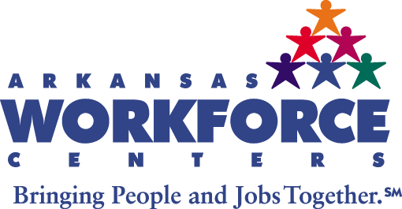
  Southeast Arkansas Locations
  Contact the Workforce Center nearest to you for assistance and services.
  Arkansas Workforce Center at Pine Bluff
  1001 Tennessee St./P.O. Box 9028
  Pine Bluff, AR 71601
  (870) 619-4803
  Arkansas Workforce Center at Monticello
  477 S. Main St./P.O. Box 619
  Monticello, AR 71655
  (870) 224-7075
  Arkansas Workforce Center at Dumas
  130 W. Waterman/P.O. Box 10
  Dumas, AR 71639
  (870) 619-4487
  Arkansas Workforce Center at Crossett
  304 N. Alabama/P.O. Box 1220
  Crossett, AR 71635
  (870) 619-4737
  Arkansas Workforce Center at Lake Village
  308 Main St./P.O. Box 806
  Lake Village, AR 71653
  (870) 619-4744
  Southeast Arkansas Economic Development District is an EEO- Equal Opportunity Employer/Program. Auxiliary aids and services are available upon request from individuals with disabilities.
  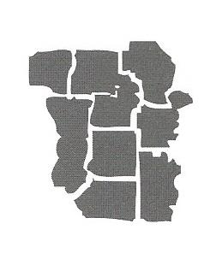
  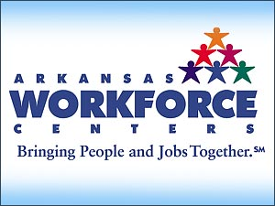
  Southeast Arkansas Economic Development District
  Workforce Development Division
  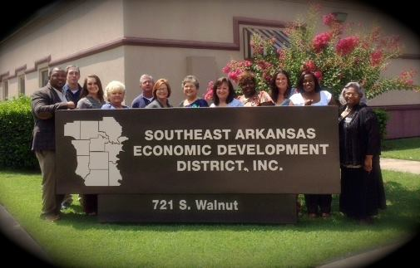
  Employer Services  Arkansas Workforce Centers provide a number of services to employers that can eliminate time and cost associated with recruiting and hiring new employees. The staff of our centers will work with employers individually to design and implement a recruiting process that best meets the needs of the employer. Some of the services available to employers include:  - Free Job Posting/Advertising  - Screening Applicants  - Pre-Employment Testing  - Referrals of Qualified Applicants  - Job Fairs  - Interviewing Facility  - Labor Market Information  - & More  These services are available at no cost to the employer.  “Connecting Employers with Qualified & Skilled Employees” |  |  | Workforce Investment Act (WIA) Programs  Adults & Dislocated Workers  Applicants who qualify for Adult &Dislocated Worker services (based on WIA eligibility criteria) may receive career readiness training including but not limited to: assistance with college tuition, books and other education related fees. This program is designed to assist individuals who have barriers to employment or who have been terminated or laid off from an employer, gain the skills and education needed to secure substantial employment and stable careers. WIA partners with institutions and training providers throughout the state to provide post-secondary educational opportunities to qualified applicants.  Youth  Youth between the ages of 14-21 who qualify for WIA Youth Program Services receive career readiness training from experienced Youth Advocates and staff who work with clients on a personalized basis. Services offered to youth are:  - Summer Job Placements  - Mentoring  - Career Counseling & Assessments  - Basic Skills Tutoring  - College Prep Seminars    - Employability Courses  - & More |  |  |   CUSTOMER SERVICES  Services Available to All Customers Include:  - Resume’ Development  - Job Search Assistance/Job Placements  - Internet Access  - Exposure to Post-Secondary Education  - Employability Skills  - Interviewing Techniques  - Computer Lab  - Job Counseling  - Employment Preparation  - Workshops  - Career Readiness Certificate  - Microsoft IT Academy  - Selective Service Registration  *All services are free to customers  Workforce Center Hours of Operation  Monday-Friday  8:00AM-4:30PM


